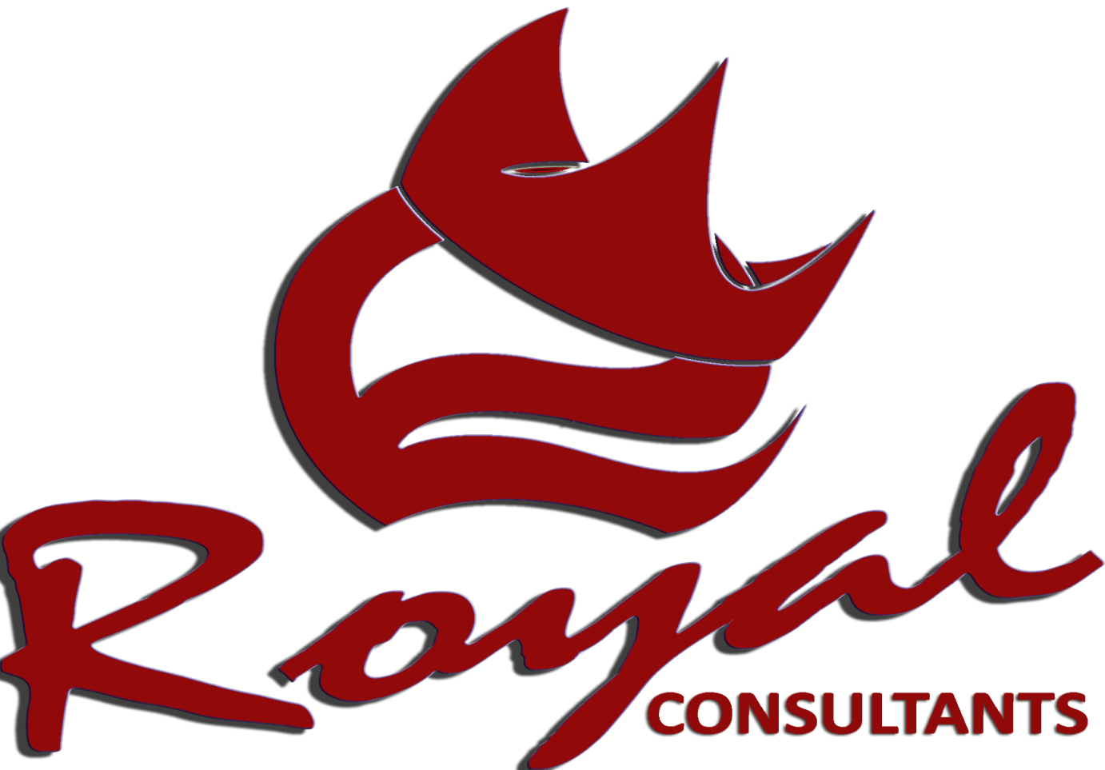

*BUSINESSPROFILE*

FF - 683, Dean’s Trade Center, Saddar Road, Peshawar Cantt.

Phone: 091-5603168,

Cell: 03339240736, 03005848604,

Email:[royal.consultants2001@gmail.com](mailto:royal.consultants2001@gmail.com)

[info@royal-consultants.net](mailto:info@royal-consultants.net)

Web: [www.royal-consultant.net](http://www.royal-consultant.net)

*Contents*

***ROYAL CONSULTANTS - WHO WE ARE***

Royal Consultants is well established ISO consultant services firm and offer a wide range of specialized multi-disciplinary services (having Clients in Dubai, Kabul).

Our strength is in our ability to execute consulting services to consumers and business stakeholders. Royal Consultants is determined to provide a cross-section of International Standardization Organization (ISO) quality certification services over time and its impact on production systems.

RC strive their best providing Quality Assurance Services and a whole range of other related Gap Analysis, Internal Auditing, and Consultancy Services network of consultants for many years in Big Cities, Dubai (UAE), and Kabul (Afghanistan). By keeping the highest standards for its Quality Assurance Services, RC is determined to provide high-quality Professional Services to its clients. The Main office of the company is located in Deans Trade Center Peshawar and branch offices & representatives are all over the Pakistan, and we have clients in Karachi, Hyderabad, Multan, Lahore, Rawalpindi/ Islamabad, Swat, Gadoon, Hattar, Peshawar and in Afghanistan. Simplicity, modern technology and cost efficiency are three attributes that play a vital role in the success of any organization. Our services integrate all three to meet dynamic and growing global demand. Committed to delivering innovation, Royal Consultant (RC) collaborates with its clients to help them become high-performance professional corporate and management consultant entities.

**M. Shahab Sheikh,**

**General Manager (GM)**

**Phone #: +92-91-6008786**

**Cell # 0333-9240736, 0300-5848604**

**Email:** [**royal.consultants@ymail.com**](mailto:royal.consultants@ymail.com)

Span of Services

We Royal Consultants are ISO 9001 Consultants in country and offer a wide range of specialized multi-disciplinary services like;

ISO 9001 Certification, ISO 9001 2008 QMS, ISO 14001: 2004 EMS, ISO 18001:2007 OSHAS, ISO 20000 IT, ISO 22000:2005 FSMS, ISO 27000 ISMS, ISO/TS 16949:2005, CE Marking, UL Marking, Trademark, Copyright Registration, and apart from this we offer wide range of more value-added services that meet the vital, immediate as well as log-term business and corporate needs of the clients in regional and international level.

Apart from these quality assurance services Royal Consultants are specialized by providing wide range of services like; Gap Analysis, HR Services, Compliance Services, Internal Auditing, Training & Workshops (On-line Trainings), Certification, Safety Services, Maintenance Services, and other business solution provider in all the four provinces of Pakistan. We also have branch offices in Kabul & United Arab Emirates. As a matter of fact, in the present scenario of consultancy.

Quality standards accreditation and ensuring best quality practices in these globally competitive markets are the main pillars to achieve the desired goals and objectives in the manufacturing sector and playing an important role in the long-term sustainable growth of manufacturers/producing sectors of the societies.

**RANG OF ACTIVITIES**

We are providing wide range of consultancy services in management, financial services, training and HR. We are committed with the aim of quality at the best level is our corner stone.

RC is providing various types of consultancy services like;

* Quality Management Standards
* ISO 9001:2008 Quality Management System,
* ISO 14001:2004 Environmental Management System
* ISO 22000:2005 Food Safety Management System
* ISO 18000:2007 OSHAS Occupational Safety System
* ISO 27000 ISMS
* ISO/TS 16949:2005
* Human Resource

RC is providing value-added services to their clients and creating strong environment for continuous development & growth in the production sector. RC provides valuable tested best practices expertise to our clients in the current challenging and globally competitive market, so that clients are able to gear their efforts and endeavor to access to the international business markets and improve their out-put with best quality of production.

We bring to our clients new ideas, new business models, and a new perspective. In doing so, we support the transition by actually facilitating the implementation of the solutions.

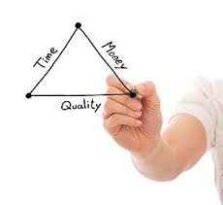

***Our Mission***

***Committing to all our customers to provide best professional services in the area of quality management system, product certification and intellectual property in compliance of our values of intelligence, sincerity and professional competency***

***Our philosophy is:***

*"Give your best to the world, and the best would come back to you ..."*

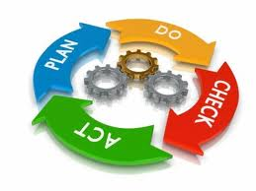Royal Consultants philosophy has always been based on the premise that real development can only be accomplished through well organized and productive organizations managed by capable personnel at all levels. This philosophy has provided the guidelines for the strategy that has directed Royal Consultants mission from the start of its operation, building the organizational Identity based on our commitment, professional culture and values.

RC mission& philosophy is to improve the operational effectiveness of our clients by developing solutions and building the internal capability of our clients. We provide best-in-class, realistic solutions that result in profitability and long-term sustainability. RC provides live, real-time strategies with integrated actions that can be rapidly executed.

The new economy demands new business models and tools, as well as new approaches to doing business. Corporations are seeking innovation and speed to capture market opportunities and meet new challenges.

***ISO Certification Advantages***

The International Standards ISO 9000, describe how companies can implement quality system. Once a system is in place, it may be certified by an independent institution. The certificates can be used to show customers that company adheres to externally verified quality standards.

**Quality Assurance**

The Quality Management System - Requirements, is widely used by organization around the world to demonstrate that they have clearly defined and well managed set of processes that enable them to consistently provide products that meet customer and applicable statutory and regulatory requirement. The value of certification is the degree of public confidence and trust that is established by an impartial and competent assessment by a third-party.

Furthermore, advantages exist in the development and acquiring of ISO Certification. The most prominent example of a certified management standard, ISO 9000, was created by the International Organization for Standardization. It specifies requirements for a quality management system in order to demonstrate that the facility can “provide products that consistently meet customer and applicable regulatory requirements” (ISO, 2002).

In-fact, International Standards brings technological, economic and societal benefits. They help to harmonize technical specifications of products and services making industry more efficient and breaking down barriers to international trade. Conformity to International Standards helps reassure consumers that products are safe, efficient and good for the environment.

**Consumer Protection**

[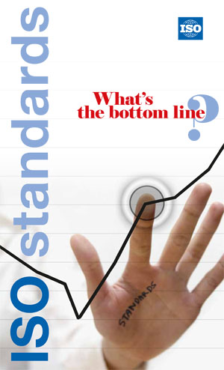](http://www.iso.org/iso/bottom_line.pdf)ISO certification prevents larger interest of consumer and protects their demands. International Standards help improve quality, enhance customer satisfaction and increase sales as well improve market credibility and shares in markets.

International Standards bring technological, economic and societal benefits. They help to harmonize technical specifications of products and services making industry more efficient and breaking down barriers to international trade. Conformity to International Standards helps reassure consumers that products are safe, efficient and good for the environment.

**Management Satisfaction**

International Standards are strategic tools and guidelines to help managements of the companies tackle some of the most demanding challenges of modern business. They ensure that business operations are as efficient as possible, increase productivity and help companies’ access new markets. Through ISO certification companies would be able to improve their products quality, reduce cost, and improve operational activities, access to new markets, new market environment and sales shares. Thus improve the overall production sales in the market resulting management satisfaction. SO has 20,000 standards touching almost all aspects of daily life. When products and services conform to International Standards consumers can have confidence that they are safe, reliable and of good quality. For example, ISO's standards on road safety, toy safety and secure medical packaging are just a selection of those that help make the world a safer place.

EXPERTS

**Royal Consultants** philosophy has always been based on the premise that real development can only be accomplished through well organized and productive organizations managed by capable personnel at all levels. This philosophy has provided the guidelines for the strategy that has directed **Royal Consultants** mission from the start of its operation, building the organizational Identity.

We believe that strength of a professional services firm comes from the experience and expertise of its staff. Keeping this in mind we have a team of highly skilled professionals who have proven record in their respective areas of expertise.

Our professional experts and consultants review the requirement and core needs of the their organizations in various fields of economy and different sectors of the societies i.e. manufacturing, industries, school, colleges & educational institutes, hospitals and medical equipment’s manufactures, construction companies, marine services, logistics, electrical and electronics companies, software development companies, health and fitness clubs and chemical industries etc.

Our Multi-disciplinary team of professionals comprising of MBA’s, Engineers, CA’s, IT consultants is well equipped with the requisite business and technical skill experience and knowledge base to deliver competencies,

Our professionals are capable of developing the required commutative advantage and sustainable value for wide range of businesses.

*A Professional Team Work through Quality Assurance Services is the Key of Success in Product Market*



RC employs professionals who specialize in each area of its services. Before being employed, each one's professional background is thoroughly reviewed, to make sure that the person being employed can keep up the highest standards maintained by RC managements. Advancing technology is rendering a lot of antiquated professional standards obsolete. Today's professional has to be dynamic, at par with ever-changing requirements. Professionals at RC keep in touch with the contemporary standards by subscribing to the latest Quality Assurance Services.

ORGANIZATIONAL CHART

*Focal Person*

***M. Shahab Sheikh***

General Manager (GM)

Phone #: +92-91-6008786, 5603234

Cell # 0333-9240736, 0300-5848604

Email: [royal.consultants@ymail.com](mailto:royal.consultants@ymail.com)

**THE END**